Autonomous Legged Guide Robot

B. Ma, S. Zhang, X. Yao, Y. Wang, Y. Bi,  *Boston University*

**Project Summary** — The robot software to be developed will allow the legged robot to navigate through different settings including sidewalks, hallways, stairs, etc. The robot can help blind people by following them and assisting them to go through those areas. The cost of implementing such a robot will be significantly less than training guide dogs while the functionality of it will exceed the ones that an electronic cane obtains.

—————————— ◆ ——————————

# 1 Need For This Project

ight is one of the most important senses in our daily life. Such as reading books, doing sports, enjoying entertainment, using computers, etc. In order to do any of those, we need our sights. However, for visually impaired people, these interactions can be extremely onerous. Moreover, among all inconveniences experienced by people with visual impairment, mobility reduction has been one of the most severe issues. Due to the necessity of movement, scientists have been exploring numerous means to restore sufficient mobility for the visually impaired. However, all solutions that are used have certain limitations.

To guide those visually impaired people, traditional ways are using probing canes and specially trained guide dogs. However, canes are not convenient in public areas, and training dogs is extremely expensive. More importantly, none of these ways have the ability to navigate. Dogs can remember some routes that the person usually walks, but when changing to a new environment, we need to retrain the dog, and it takes time with uncertainty. These all provide inconvenience of going out or even indoors (like in a building). So we need a solution that is convenient to use for blind people, cheap and reliable.

# 2 Problem Statement and Deliverables

Visually impaired people are one of the most common parts of disabled people whose lacking sight may bring a lot of inconvenience in their lives. Some seemingly normal actions may be extremely onerous to visually impaired people, including reading books, playing sports, and so on. Among these actions, the most severe issue is mobility reduction: the lack of sight makes visually impaired people fear moving. Scientists have already developed several ways to help these people and build confidence for them, such as using probing canes and specially trained guide dogs. However, canes are not convenient in public areas, and training dogs is extremely expensive, and one of the most severe problems is that dogs can’t navigate visually impaired people to places that they have never been to. Thus it inspires us to develop such an autonomous legged robot to help with navigation.

To make visually impaired people move around more conveniently, our autonomous legged robot will act as a clever dog to guide the visually impaired people and give instructions about the position of obstacles and time to veer. Our first function is to make it get to the destination planned by the visually impaired people. The user interface may be operated by audio message. We would embed the ability to store/learn the map at least in a small block first (expand the range according to the process), which is the advantage over guiding dogs since dogs can’t remember the routes it hasn't gone to. And also, the reason for choosing a legged robot instead of a motor vehicle is that a legged robot can overcome some tough routes, including going up and down the sidewalks. And our second main function is obstacle detection and avoidance. We may use Oak-d cameras paired with machine learning training models to detect the obstacles within a certain amount of distance and give hints back to the visually impaired people when and how to veer or stop by. Also, for the legged robot itself, we would first try to make it steer by the resting obstacle like a pillar and go back to its original planned route.

# 3 Visualizations

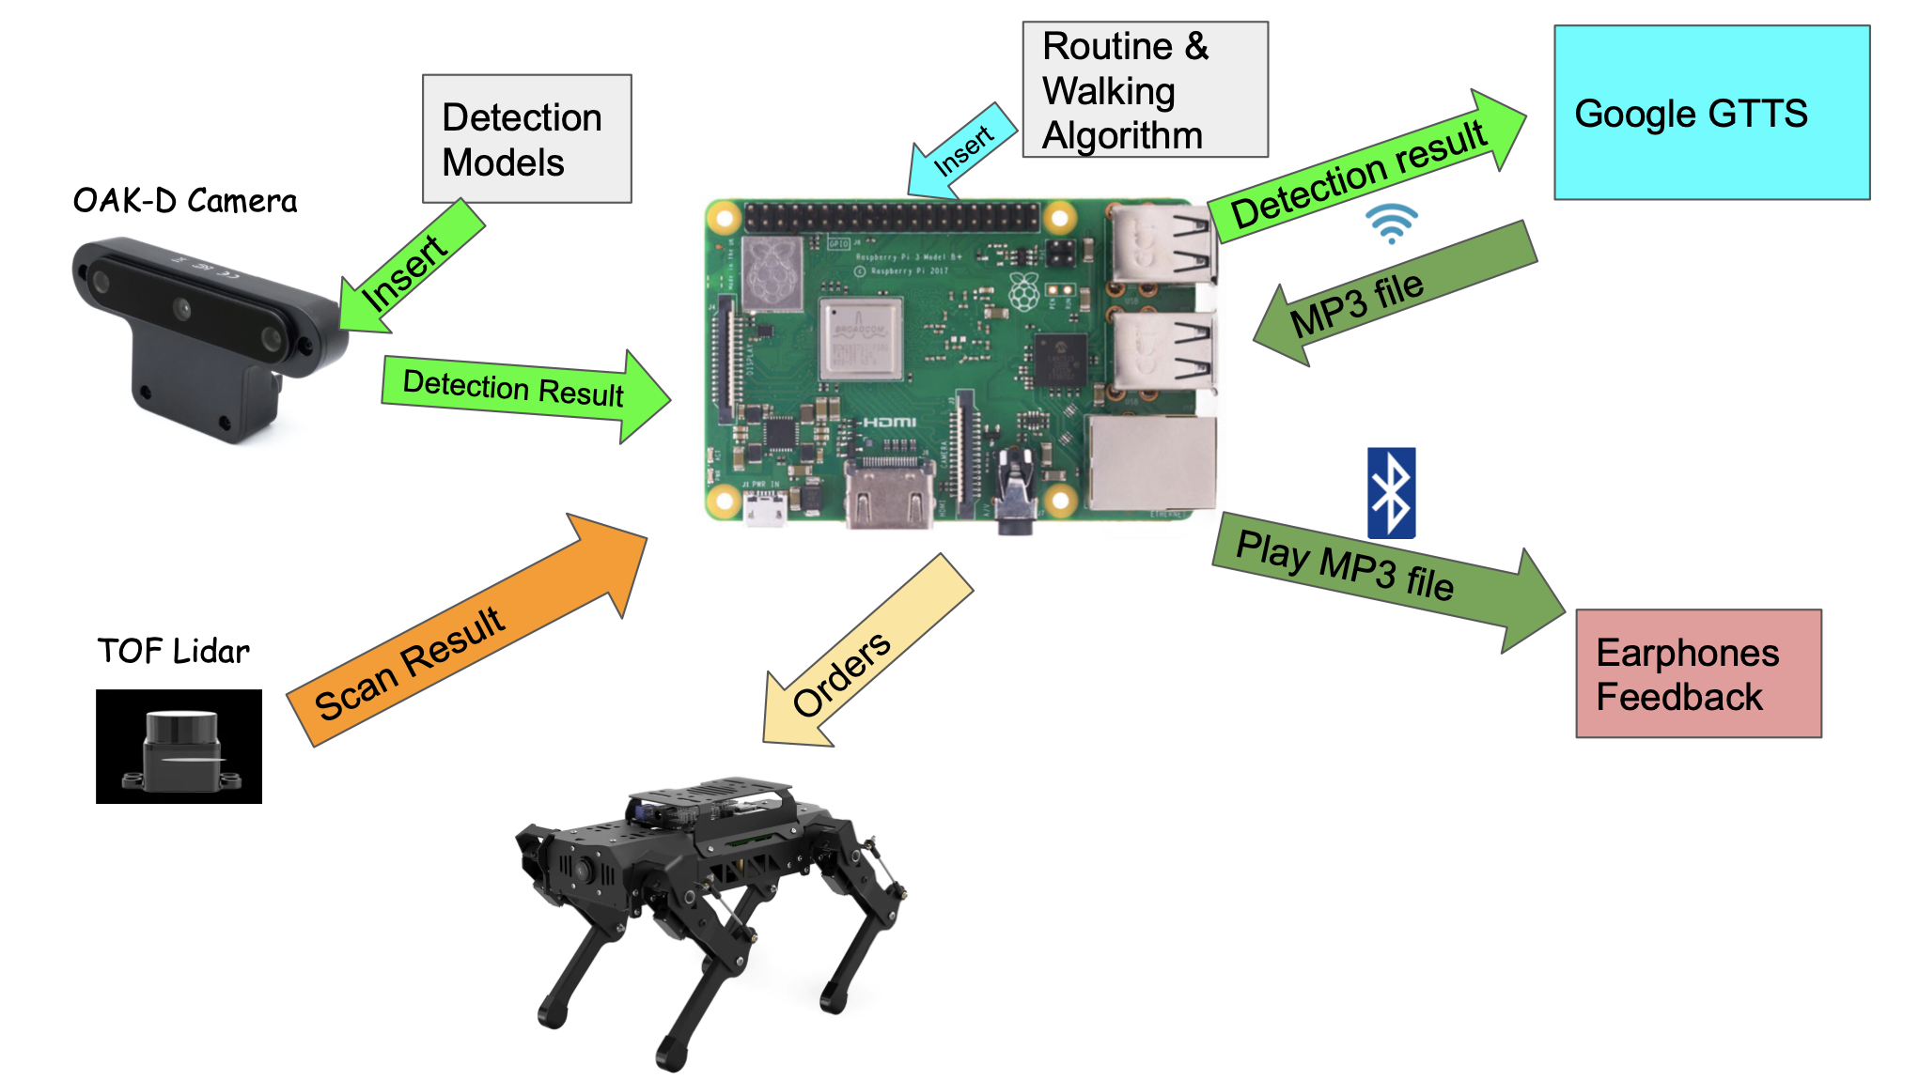

Fig. 1 Designed system

As Shown in Fig 1, Our system uses two sensors, an OAK-D camera and a TOF lidar sensor. OAK-D is embedded with a neural network processor and with a detection model, YOLO V3, for example, inserted. It is able to give the detection result to the Raspberry Pi so it can help the dog to “see.” The TOF lidar, on the other hand, gives lidar feedback to the Raspberry Pi and we can do a slam map so we can get a rough idea of what the environment around it looks like. The Raspberry Pi is embedded with our set routine and walking algorithm to walk and avoid obstacles. It then passes orders to the Robot dog which uses a ROS system to control. With the feedback of the OAK-D, the system generates wording information like “there is a pole 2 meters ahead”. The Raspberry Pi will be connected to a Wifi or Hot-pot to access Google GTTS library to convert it into a MP3 file and send it back. It can then play it to the user via a bluetooth connection to an earphone to give voice feedback.

# 4 Competing Technologies

## 4.1 Guide Dogs

A service dog is a dog specifically trained to perform work for a person with a disability. For visually impaired people, guide dogs can usually work to guide their owners to walk outside. Their owner can follow the guidance of the guide dogs to move safely from one location to another.

Although guide dogs have been used for a long time, it has some special requirements and restrictions that limit them from being widely used. Guide dogs usually require a lot of training. According to the International Association of Assistance Dog Partners (IAADP) guidelines, training a service dog requires a minimum of 120 hours of training for at least 6 months [1]. Also, training service dogs is very costly. It may cost up to $25000 to train a service dog [2]. The high cost and the long training time make it difficult for most visually impaired to afford a guide dog.

Apart from the cost and time needed to train the dog. Guide dogs also have a limited ability to guide people. Since dogs can only be trained to remember a limited number of roads, it will be impossible for them to guide people outside the area they know. In addition, since dogs cannot be trained to recognize signs on the road and react accordingly, they may guide people wrong at pedestrian crossings. This could be dangerous if the user is in heavy traffic.

## 4.2 Electronic Canes

Another competing technology is the electronic guiding cane. One example is UltraCane by Sound Foresight Technology Ltd in the UK[3]. According to their introduction, “the UltraCane is an electronic long white cane for use by people who are blind or visually impaired and is THE ONLY electronic long white cane that utilizes state of the art ‘narrow beam technology’''. The cane emits ultrasonic waves to detect obstacles within a 2 to 4 meters range. With this information, visually impaired people can guide themselves and avoid hitting any obstacles in their way.

Although UltraCane can help visually impaired people in many ways, their product still has some limitations. One is the accuracy of ultrasonic sensors. Experiments show that the accuracy of ultrasonic sensors can be influenced by temperature, humidity, and other factors [4]. The inaccuracy in sensors causes the cane to be unable to provide accurate information about the road. This might be a problem if visually impaired people are walking on some damaged roads.

Apart from this problem, ultrasonic canes can only sense objects but cannot recognize images. The product shares the same problem with guide dogs. Users of the product cannot know the traffic lights and signs on the road. This may lead to a problem if they are crossing a busy pedestrian crossing.

# 5 Engineering Requirements

## 5.1 Objectives

This project aims to investigate and develop the implementation of artificial intelligent robotics in the software engineering aspect. The main goal is to improve the living quality of visually impaired people, specifically in the area of daily navigation by developing an affordable, which indicates a price of no more than $750, quadrupled self-navigation robot with stable durability of over 3 years of daily usage. We believe the implementation of the OAK-D camera, TOF lidar sensor, and the embedded neural network processor will already improve the performance of our product in terms of object identification and obstacle avoidance. We will also obtain a built-in slam map in our product capable of storing routing information of 500-meter radius. With the above technologies implemented, we expect our product to match at least the navigation capability of guide dogs and the durability of normal electronic canes.

## 5.2 Functional Requirements

In the design phase of our product, following functionality requirements should be satisfied:

1. The product shall have built-in slam maps capable of navigating to destinations of under 500m straight-line distance.
2. The product shall incorporate one or more TOF lidar sensors to detect incoming objects and obstacles within 5 meters from all directions.
3. The product shall be capable of climbing up and down normal height sidewalks/stairs of 25cm.
4. The product shall have a waterproof level to ensure proper functionality under 5 cm precipitation.
5. The product shall be capable of connecting to phones/earphones based on the latest Bluetooth 5.2 standard for sound direction.
6. The product shall offer an automatic charging station that the robot is capable of self charging when battery is under 10%.

## 

## 5.3 Constraints and Metrics

During the actual implementation of our product, the list of constraints below should be considered:

1. The cost of all materials utilized to build the robot should not exceed $750.
2. The product should have a presentable prototype with more than 80% of functions implemented by March 31st, 2023.
3. The overall weight of the product should not exceed 20 kg.
4. The durability of the product should be no less than 3 years of daily usage.
5. The product should be regulated by OSHA standards.

# 6 End Sections

## 6.1 References

1. IAADP, “IAADP minimum training standards for public access,” The International Association of Assistance Dog Partners (IAADP), 09-Jun-2022. [Online]. Available: https://iaadp.org/membership/iaadp-minimum-training-standards-for-public-access/. [Accessed: 14-Oct-2022].
2. Service dog certification, “How much does it cost to train a service dog,” Service Dog Certifications, 25-Feb-2022. [Online]. Available: https://www.servicedogcertifications.org/how-much-does-it-cost-to-train-a-service-dog/. [Accessed: 14-Oct-2022].
3. SuperCane, About the UltraCane. [Online]. Available: https://www.ultracane.com/about_the_ultracane. [Accessed: 14-Oct-2022].
4. “Ultrasonic sensor accuracy,” Senix Ultrasonic Distance and Ultrasonic Level Sensors, 30-Mar-2022. [Online]. Available: https://senix.com/ultrasonic-sensor-accuracy/. [Accessed: 14-Oct-2022].